Department of Environmental Science

University of Kashmir, Srinagar:-190 006

Notice: Environ Sci/Exam GE/2018
Dated :6/7/2018

It is for the information of those who have not attended any class in Herbal medicine, ENS15409GE Course offered by Environmental Science under the guidance of Prof B.A Ganai, will not be allowed to sit in the examination to be held on (11or 14)/7 /2018.
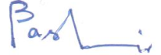
Professor Bashir Ahmad Ganai
Teacher Incharge

