# **FIST Funded NAAC Accredited ‘A’**

 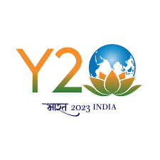

# **Tel: (O) 0194- 2272386; 0194-2272387ku.png Cell No: 91 9596013427**

# **Email:** [**samiullahbhat11@gmail.com**](mailto:samiullahbhat11@gmail.com); [**samiullah@kashmiruniversity.ac.in**](mailto:samiullah@kashmiruniversity.ac.in)

## Department of Environmental Science

# **University of Kashmir**

**Dr. Sami Ullah Bhat**

**Assistant Professor**

# **Hazratbal Srinagar -190006**

**Accredited FAE (WP)**

No:KU/Env./SERB/JRF/23

Dated: 31-03-2023

**Extension Notice**

The last date of the forms for the position of 01 position of Junior Research Fellow (JRF) for a period of one year initially extendable to two years subjected in the project **“Status, Threats and Challenges Urgent Plea for Protection and Management of Freshwater Springs of Kashmir Himalaya”** advertised vide No:KU/Env./SERB/JRF/23 dated 31/03/23 is extended upto 15/05/2023.

**Sd**

**Dr Sami Ullah Bhat**

**Co-Principal Investigator**

**SERB-DST Project**

**Sr. Assistant Professor**

**Department of Environmental Science**

**University of Kashmir**

**Srinagar**

**Email:** [**springshimalaya@gmail.com**](mailto:springshimalaya@gmail.com)