# **FIST Funded NAAC Accredited ‘A’**

 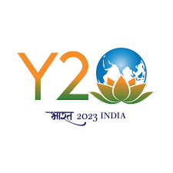

# **Tel: (O) 0194- 2272386; 0194-2272387ku.png Cell No: 91 9596013427**

# **Email:** [**samiullahbhat11@gmail.com**](mailto:samiullahbhat11@gmail.com); [**samiullah@kashmiruniversity.ac.in**](mailto:samiullah@kashmiruniversity.ac.in)

## Department of Environmental Science

# **University of Kashmir**

**Dr. Sami Ullah Bhat**

**Assistant Professor**

# **Hazratbal Srinagar -190006**

**Accredited FAE (WP)**

No:KU/Env./SERB/JRF/23

Dated: 15-05-2023

**Interview Notice**

The interview of the candidates who have applied and found eligible in response to advertisement notice No: KU/Env./SERB/JRF/23 dated 31/03/23 for Junior Research Fellow (1 position) in project titled "Status, Threats and Challenges: Urgent Plea for Protection and Management of Freshwater Springs of Kashmir Himalaya" sponsored by SERB-DST Govt. of India shall be held on **16-05-2023** (Tuesday) at 3 pm in the office of the Head, Department of Environmental Science, University of Kashmir Srinagar. The candidates should bring their original documents/testimonials/credentials along with them on the date of interview.

No TA/DA will be provided for appearing in the interview.

**Sd**

**Dr Sami Ullah Bhat**

**Co-Principal Investigator**

**SERB-DST Project**

**Sr. Assistant Professor**

**Department of Environmental Science**

**University of Kashmir**

**Srinagar**